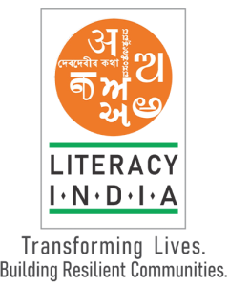Literacy India community college



Programs offered

* Robotics/Tinkering
* Computer hardware
* Mobile repairing
* 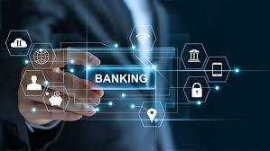Cooking /Hospitality
* Beauty and wellness
* Stitching and cutting
* Electrical troubleshooting
* Mobile journalism
* Computer science
* Call centre/BPO
* Logistics
* Data digitization
* Natural Farming Market Connect
* Banking

[www.literacyindia.org](http://www.literacyindia.org)

Register Now Session starts from

January 2024

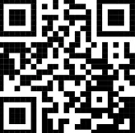

CONTACT NO. 8588853380